
Resilience in the Age of Generative AI
Trust and output quality become as critical as system uptime in continuity planning
Ten ways GenAI is reshaping resilience
- Expanding the definition of resilience
- Silent degradation as the new failure mode
- External dependencies and concentration risk
- Knowledge erosion and human dependency
- Rising regulatory expectations
- Continuous model drift
- Ethical and reputational resilience
- Data dependency and lineage complexity
- Scenario testing for AI failure modes
- Convergence of risk, operations and compliance
The three pillars of AI-era resilience
Data: Traceable and validated against bias
People:
Trained to intervene and fallback
Models:
Monitored for drift and transparency


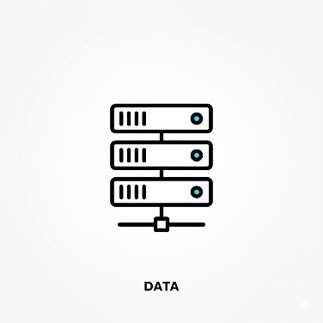
The BIP resilience means harmonizing models, data, and people to sustain operations through volatility.


Resilience in the Age of Generative AI: Why Service Integrity is the New Uptime
By BIP — Operational Resilience & AI Risk Practice Insight
October 2025

The Shift from System Availability to Service Integrity
For decades, operational resilience has been defined by infrastructure stability — uptime, recovery time objectives (RTO), and disaster recovery. In the age of Generative AI (GenAI), that definition is no longer sufficient.
As large institutions integrate AI into critical services — from fraud detection and client communications to liquidity forecasting — resilience is no longer just about keeping systems online. It’s about ensuring the integrity and reliability of outcomes when algorithms, data, and human operators interact in complex, adaptive ways.
Generative AI introduces a fundamentally different risk dynamic. Systems no longer fail only through outages or latency. They can degrade silently, producing inconsistent, biased, or inaccurate outputs while remaining fully operational. This redefines what “continuity” means: a service can be available but untrustworthy.
In this new era, operational resilience must expand to include what BIP calls Service Integrity — the ability of AI-enabled services to deliver consistent, transparent, and trustworthy outcomes even under stress or drift.

Ten Emerging Impacts of GenAI on Resilience Programs
Our recent engagements with leading global banks and capital markets firms reveal ten distinct ways GenAI is reshaping operational resilience frameworks.

1. Resilience Now Encompasses Quality, Not Just Availability
Traditional resilience focused on physical infrastructure and application uptime. With GenAI, the new challenge is output integrity. A system that’s running but generating degraded or non-compliant results is effectively “down.”
Leaders are redefining continuity metrics to include accuracy, factuality, and bias thresholds — tracking not just availability but the trustworthiness of AI-driven outputs.

2. New Failure Modes: Silent Degradation
AI models can fail silently. They may drift as training data evolves, or respond unpredictably to new prompts or contexts. Unlike a server crash, this degradation often goes undetected until it affects customers or compliance.
Resilience teams must add behavioral monitoring and anomaly detection alongside traditional technical monitoring.

3. Rising Third-Party and Concentration Risk
Most large firms rely on external AI providers. That creates an invisible layer of dependency: if a model like GPT-4 or Claude changes behavior, every process built on it changes too.
Institutions must extend third-party risk frameworks to include model version controls, change notifications, and exit strategies.
Concentration risk — overreliance on a single AI vendor — is the new single-point-of-failure.

4. Knowledge Erosion and Human Dependency
As GenAI automates complex tasks, human expertise risks atrophying. When outages occur, few may remember how to perform key processes manually.
Leading firms are addressing this through “knowledge resilience” — rotating staff through manual-mode operations, running quarterly human-in-the-loop (HITL) drills, and maintaining detailed fallback playbooks.
The goal: ensure people can still perform if the AI cannot.

5. Expanding Regulatory and Governance Pressure
Global regulators are moving rapidly.
- In the U.S., the Federal Reserve’s SR 11-7 guidance on model risk is being interpreted for AI systems.
- The EU’s DORA and AI Act emphasize third-party resilience and algorithmic transparency.
- The Basel Committee (BCBS) and NIST AI Risk Management Framework stress testing, explainability, and operational assurance.
While explicit AI resilience regulation remains nascent, the direction is clear: institutions must be able to demonstrate control, monitoring, and fallback capability for their AI systems.

6. Continuous Model Drift as a Resilience Risk
Drift — when model outputs change due to new data, retraining, or environmental shifts — introduces non-determinism into risk frameworks.
Even minor drift can impact client outcomes or decision quality. Leading firms now treat drift as a resilience event, monitoring it like a performance degradation rather than a technical failure.
Best practice includes version tracking, golden datasets for periodic testing, and automated drift alerts integrated into resilience dashboards.

7. Ethical and Reputational Resilience
A GenAI model may be technically functional yet reputationally catastrophic.
Examples include biased credit recommendations, insensitive customer communications, or hallucinated legal advice.
Resilience must therefore expand to ethical and reputational dimensions — incorporating bias detection, content filters, and escalation protocols for “behavioral incidents.”
Some institutions are now adding “reputation impact” as a factor in their impact tolerance metrics.

8. Data Dependency and Lineage Complexity
GenAI intensifies reliance on data pipelines.
A small change in data quality, labeling, or source systems can silently alter AI behavior.
Resilience programs must therefore extend into data continuity, including lineage mapping, input validation, and fallback data feeds.
The objective: ensure model reliability even when upstream data sources are disrupted.

9. Expanded Scenario Testing and Tabletop Exercises
Traditional resilience tests simulate data-center outages or cyber events.
Next-generation programs now include AI-specific failure simulations — model drift, hallucination spikes, or vendor API outages.
Cross-functional “red team” simulations involving AI risk, tech ops, and compliance are emerging as a new norm in financial services.

10. Convergence of Functions: A New Operating Model
Perhaps the most important shift: resilience can no longer operate in isolation.
AI systems sit at the intersection of business, technology, and risk. Managing them requires cross-functional governance that unites:
- Operational Continuity & Resilience (OC&R)
- AI Risk and Model Validation
- Technology Operations
- Third-Party Risk and Compliance
Leading institutions are establishing Enterprise AI Operating Models — complete with RASCI matrices that define accountability for monitoring, decision-making, rollback, and communication during AI disruptions.

From Engineering to Intelligence Resilience
Generative AI transforms resilience from an engineering challenge into a systems intelligence discipline.
Recovery is no longer about restarting servers; it’s about detecting, interpreting, and correcting behavioral drift across complex, adaptive systems.
Forward-looking organizations are investing in three foundational capabilities:
- Managed AI Triggers — criteria to determine when a model becomes “resilience-managed.”
- Quality-Based Impact Tolerances — thresholds for degradation in accuracy, bias, or factuality.
- Cross-Functional Governance — unified processes that ensure alignment between business continuity, AI risk, and compliance.
This approach allows firms to focus resources where they matter most: AI-enabled services supporting Prioritized Critical Services (PCS) such as trading, payments, and client onboarding.

Building Resilient Intelligence Systems
Institutions that thrive in the GenAI era will treat resilience as a living, learning system.
They will combine automated detection with human oversight, align resilience controls with AI governance and ethics, and develop testing regimes that simulate not just downtime, but drift and degradation.
In this environment, the question is no longer “Can we recover?”
It is “Can we trust what our systems produce under stress?”

The BIP Perspective
At BIP, we define AI-era resilience as the harmonization of models, data, and people — ensuring all three can adapt, recover, and continue to perform during disruption.
Service integrity becomes the cornerstone of operational continuity.
Organizations that master this shift will not only meet regulatory expectations — they will earn something far more valuable: enduring client and stakeholder trust.
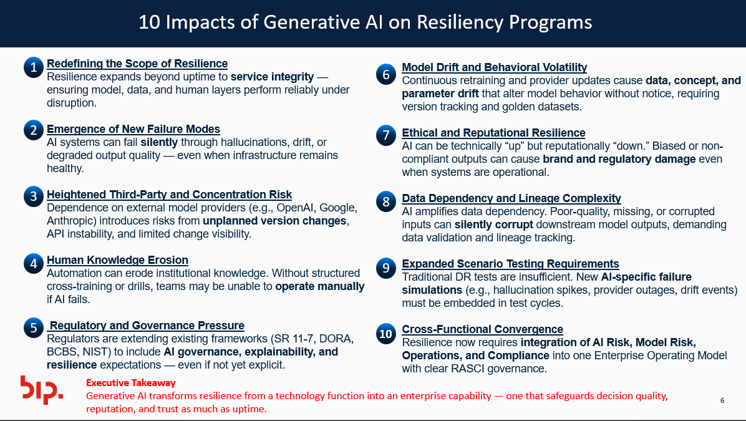

Discussion Details

Impacts of Generative AI on Resiliency Programs in Large Corporations

1. Redefining the Scope of Resilience
Traditional resilience programs were built around system availability and disaster recovery. Generative AI (GenAI) extends this to output reliability and trust.
- Then: “Is the system up?”
- Now: “Is the system behaving correctly even when it’s up?”
Resilience now must cover algorithmic stability, data quality, and AI decision integrity, not just infrastructure continuity.

Implication:
Resilience frameworks must evolve from a tech-centric model (uptime, RTO/RPO) to a service-integrity model—where AI model health and human oversight are as critical as server uptime.

2. Emergence of New Failure Modes
GenAI systems fail differently than traditional IT systems. They can degrade silently without technical outages, creating “quality failures” instead of availability failures.
Traditional Failure | AI-Driven Failure
Server outage | Model drift or degraded accuracy
Network latency | Increased hallucination rate
Data corruption | Loss of factual consistency or bias creep
Human error | Over-reliance on automated AI output

Implication:
Incident detection must expand beyond monitoring system metrics to include behavioral monitoring—tracking deviations in AI responses, factuality, or tone.

3. Increased Third-Party and Concentration Risk
GenAI relies heavily on external model providers (OpenAI, Anthropic, Azure, Google Cloud).
These dependencies introduce new forms of operational exposure:
- Model updates outside the bank’s control
- API instability or latency during high-load periods
- Legal, jurisdictional, or ethical risks in multi-cloud environments

Implication:
Resilience programs must include AI supply-chain governance, contractual change-notification SLAs, and fallback strategies (e.g., model redundancy, “last-known-good” version storage).

4. Human Knowledge Erosion
When AI automates critical processes, institutional knowledge can decay.
If the AI system fails, the human operators may lack the context or skill to recover operations manually.
This risk compounds over time as AI dependency deepens.

Implication:
Resilience programs must explicitly address knowledge resilience:
- Regular manual-mode drills
- Human-in-the-loop (HITL) checkpoints
- Documented playbooks for non-AI fallback execution

5. Regulatory and Governance Pressure
Regulators are beginning to connect AI governance with operational resilience:
- SR 11-7 (U.S.) — model risk management principles now interpreted for AI.
- DORA (EU) — focuses on digital resilience, including third-party ICT dependencies.
- BCBS Principles (2023) — embed AI governance into risk and control frameworks.
- NIST AI RMF — establishes “trustworthy AI” as an operational goal.

Implication:
Resilience programs must align with model risk management, AI ethics, and third-party oversight functions to satisfy regulatory expectations.
This requires cross-functional governance—Resilience, AI Risk, Model Validation, and Tech Ops must operate under one framework.

6. Dynamic Model Behavior and Drift
GenAI models evolve continuously—through retraining, fine-tuning, or provider updates.
This creates non-static risk, meaning controls that worked yesterday may fail tomorrow.

Implication:
Resilience programs must:
- Implement drift detection and version tracking.
- Maintain golden datasets to benchmark expected outputs.
- Conduct canary or shadow testing to identify drift before it impacts production.

7. Ethical and Reputational Resilience
A GenAI model can be technically functional yet cause brand or regulatory harm (e.g., biased or inappropriate outputs).
Resilience, therefore, must include reputation protection and ethical safeguards.

Implication:
Incorporate content filters, bias audits, and ethical escalation protocols into resilience runbooks.
Crisis management plans must cover reputational scenarios (e.g., “AI-generated misinformation incident”).

8. Data Dependency and Lineage Complexity
GenAI models amplify data dependency — relying on diverse sources and real-time ingestion.
Loss, corruption, or drift in these data feeds can silently corrupt AI performance.

Implication:
Resilience programs should expand data continuity controls:
- Implement lineage tracking and data validation before model ingestion.
- Establish data fallback feeds or “golden source” restoration points.

9. Testing, Simulation, and Tabletop Expansion
Traditional tabletop exercises focus on physical or system outages.
With GenAI, exercises must simulate quality degradation events:
- Hallucination spikes
- Model bias under stress
- Provider API disruption

Implication:
Develop an AI-specific scenario catalog within resilience testing programs, ensuring cross-functional teams rehearse both technical and decision-level failure responses.

10. Cross-Functional Convergence
Finally, GenAI collapses traditional boundaries between Risk, Ops, Tech, and Business Functions.
A drift or bias event can simultaneously affect:
- Operational continuity
- Model risk metrics
- Compliance thresholds
- Client communications

Implication:
Corporations must implement a shared governance layer that unites these disciplines under an Enterprise Operating Model (RASCI) — defining ownership, escalation paths, and decision rights across functions.

Summary: The New Paradigm
Dimension | Traditional Resilience | AI-Era Resilience
Focus | System uptime | Service integrity
Failure Mode | Downtime | Degradation or drift
Controls | Infrastructure & DR | Quality, drift, ethics, human fallback
Ownership | IT Operations | Cross-functional (Ops, AI Risk, MRM, Compliance)
Testing | Disaster scenarios | Scenario-based drift and quality simulations

Key Takeaway
Generative AI transforms operational resilience from an engineering discipline into an intelligence discipline.
Resilient organizations will not only recover from outages — they’ll anticipate, detect, and contain AI behavioral drift before it impacts clients, compliance, or trust.

